

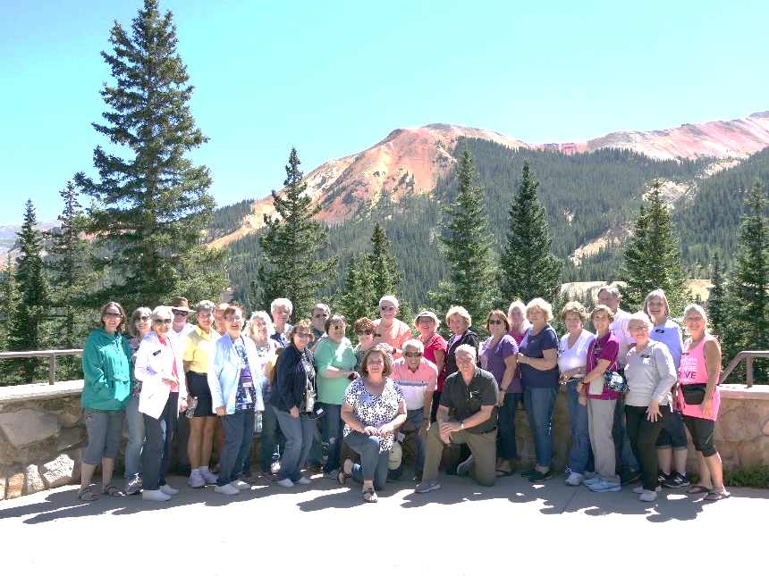
FREE GROUP TRAVEL SHOW

Friday, November 6, 2026
10:30-1:00 p.m.

Dolan Recreation Center
888 Dunbar Rd. Mundelein, IL

​Showcasing:

​
- Utah Parks & Canyons May 11-18 '27
​
- Discover Lake Huron & Michigan (by Motor Coach) June 21-25, '27
​​​​​
- ​​Colorado Trains and National Parks July 31 - Aug. 8, '27
​​​​​​​​
- ​America's Railroading Bicentennial: Pittsburgh, Gettysburg to Baltimore Oct. 17-21 '27

RSVP for Travel Show email: DestinationsWithNadine@gmail.com
or by calling 847-902-8064
​
Light Refreshments will be served at the Travel Show.
​

NOTE: Reservation Form with your $100 deposit secures your spot. Come see what these amazing tours are all about and Join the Fun!

Call Nadine at 847-902-8064 with questions and Come Join the Fun!

************

Come live your best life by joining Destinations With Nadine on our exciting Group Travel Destinations and fun Day Outings! And thank you for supporting local small businesses.

Nadine Mihaljevic
Destinations With Nadine, Inc.
847-902-8064
website: www.DestinationsWithNadine.com

